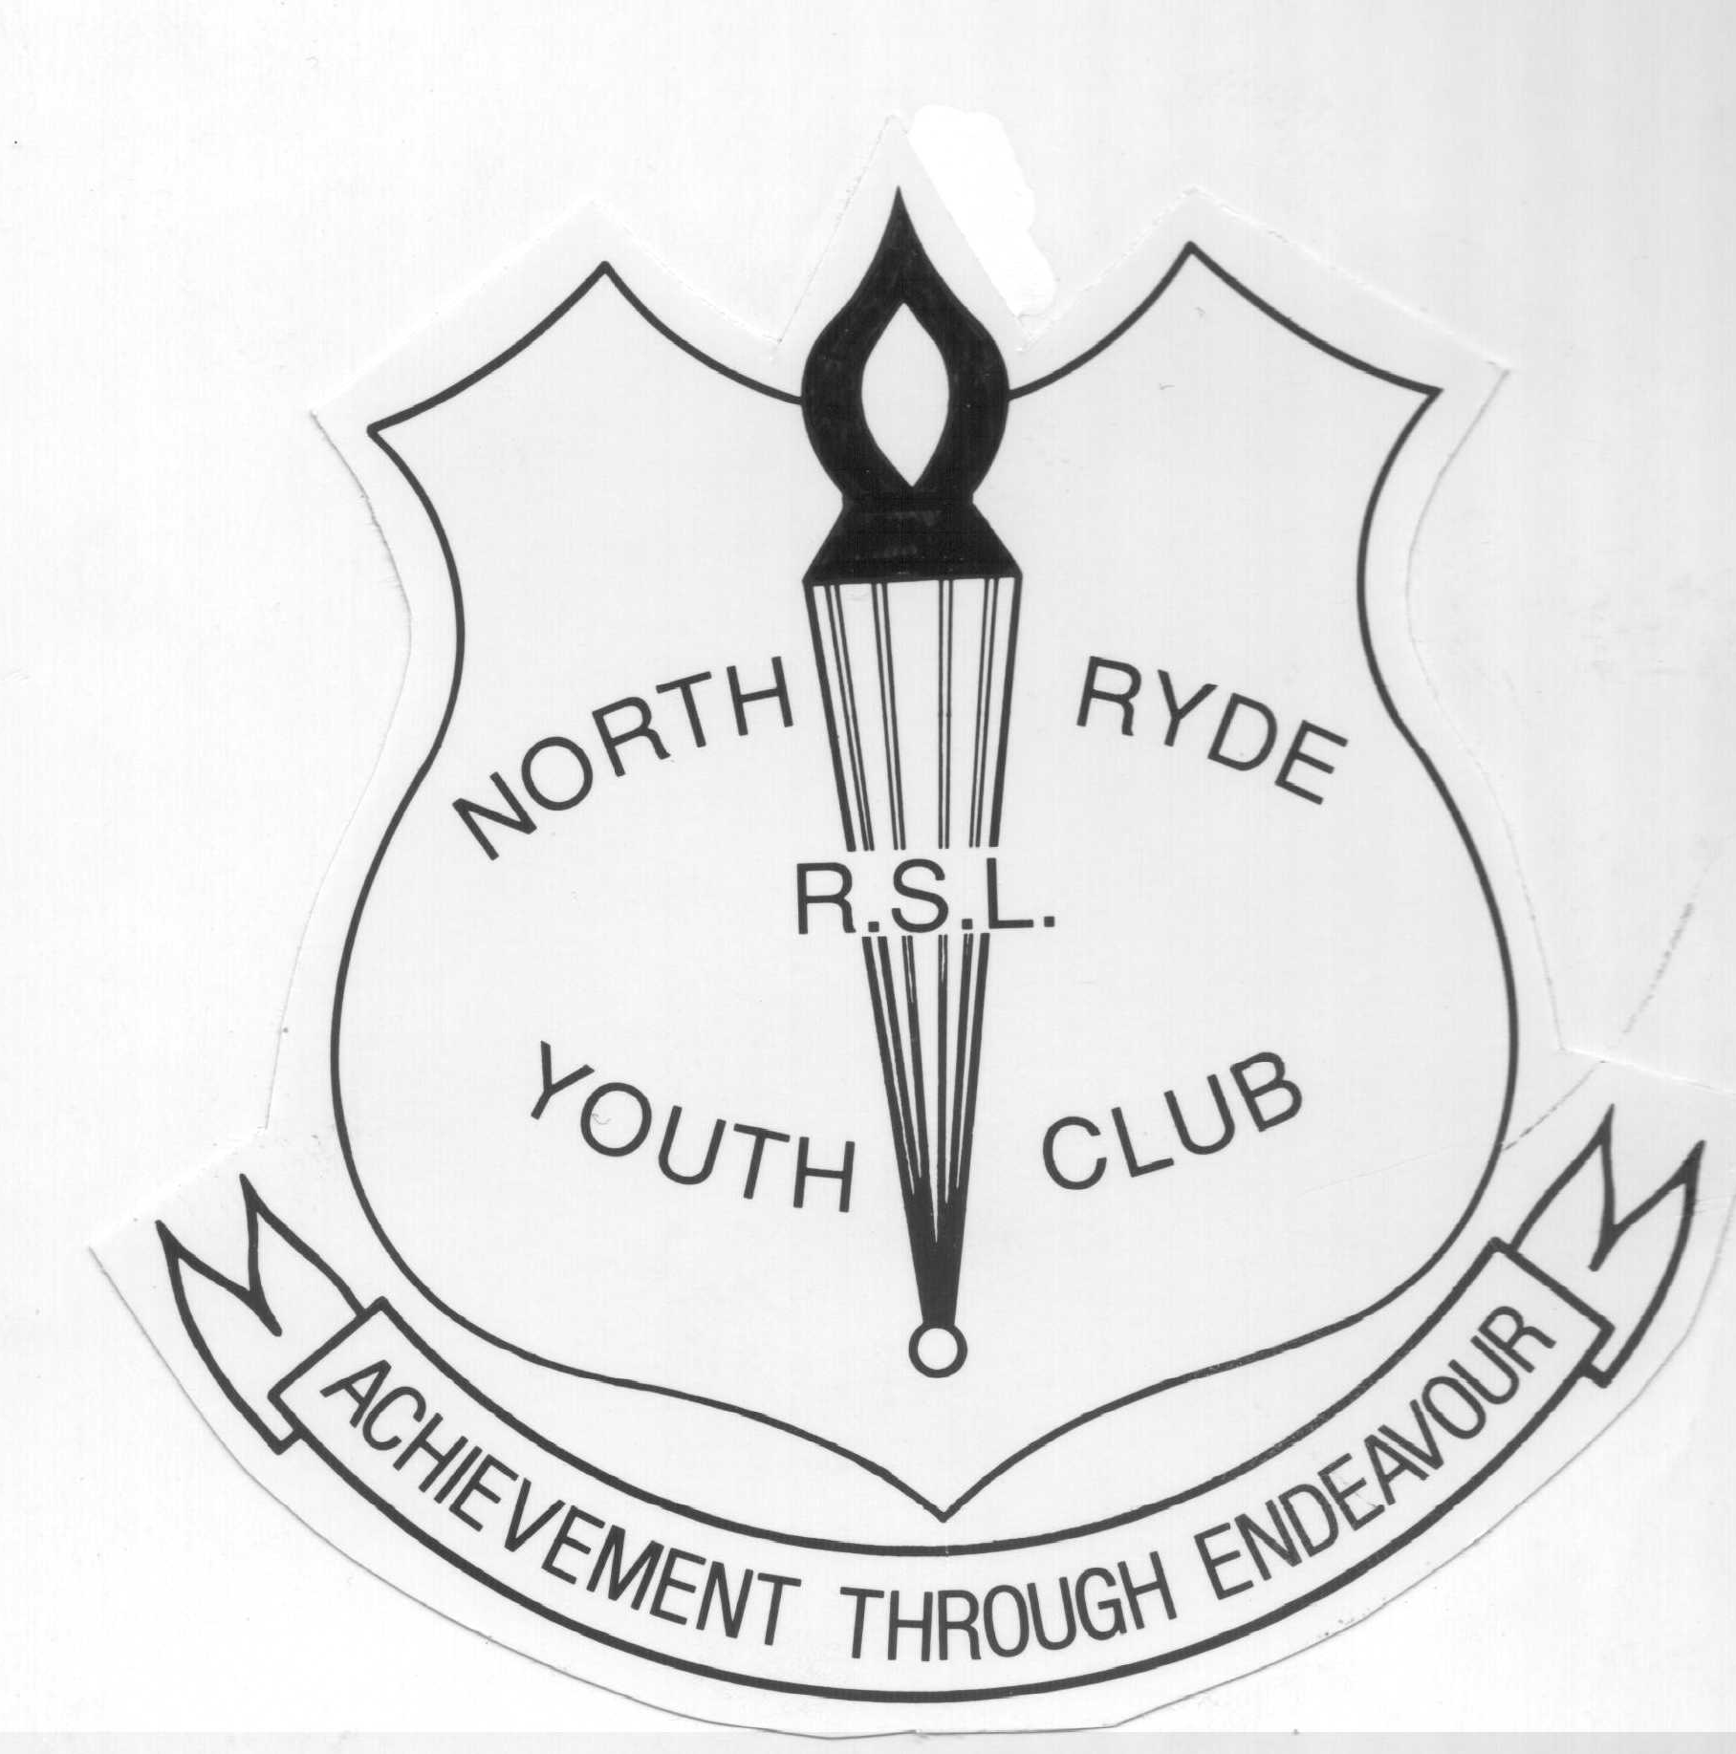

DATE PAID __________

REC NO. ____________
NORTH RYDE RSL YOUTH CLUB
ALL CORRESPONDENCE TO BE ADDRESSED TO THE HONORARY SECRETARY
PO BOX 6093, NORTH RYDE 2113 (CNR PITTWATER & MAGDALA ROAD, NORTH RYDE)
PHONE 9878 6128 FAX 9888 7952 EMAIL nrrslyc@atu.com.au www.nrrslyouthclub.org.au
ABN 92 303 454 782
MEMBERSHIP APPLICATION FORM
Youth Club Applicant/s
First Name | Surname | Date of Birth | Activities | Mem No.
Membership Fees for Current Year
Individual Membership $16 each Family Membership $40 .00 (3 or more members)

Address _____________________________________________________________________
____________________________________________ Postcode _______________________
Email ____________________________ School ____________________________________
Parent/Guardian
First Name ____________________ Surname ______________________________________
Address (If different to address above) ____________________________________________
____________________________________________ Postcode _______________________ Home Ph: ________________Work Ph: _________________Mobile Ph:__________________
Fax ____________________ Email _______________________________
General Information

- Membership is available to people between the ages of 5 and 25 years of age
- Membership fees are set annually
- Fees are renewable yearly, 1st December (renewals may be available earlier for some sections)
- Youth Club membership is compulsory prior to joining any section
- Section fees are additional to Youth Club Membership fees
- This form must be signed by a parent or guardian,
(Applicants over 18years of age may sign on their own behalf)

Indemnity
I agree that the member/s will abide by the Youth Club rules. For any injury sustained by the member/s while taking part in such activities, I guarantee to hold indemnified against claim/demand the North Ryde RSL Youth Club and it’s members, North Ryde RSL Community Club Ltd and it’s members, together with the agents, employees and officers of these clubs.

Signature ________________________________ Date __________________________

